How to transfer your old data to the newer version STJv9.6
1 – Clearing Data - Click the Clear All Data Button from “settings sheet. This will reset the file and delete all existing trades.
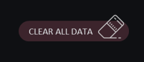
2- Bank Transfers - Go to “Bank transfers” sheet copy your old data and paste as Value. This is important so that cell format will be kept the same.
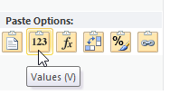
3- Adding Rows - Go to “Trade Log” sheet, the default log is 500 rows, make sure to click ADD ROW icon first before adding your data.
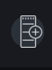
4- Trade Notes - On Trade Log notes “Reason for buying/selling”, we have set it as a dropdown notes, you can customize it in the settings sheet. If you have a more detailed note, add it in the additional note’s column
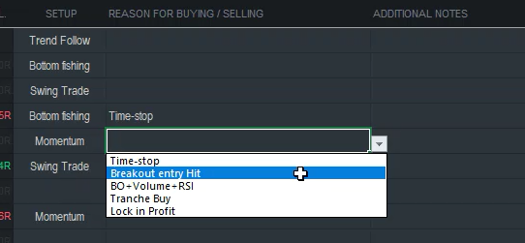

5- Default Notes - Go to settings and add your default notes in the settings sheet, this will be shown as a dropdown list in the trade log sheet.
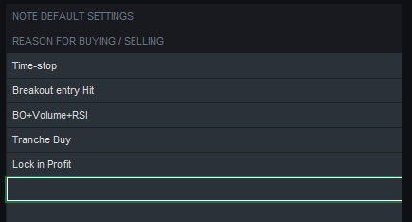

6- Dividend sheet – We have removed unnecessary columns in the dividend sheets, make sure to paste your data per column.
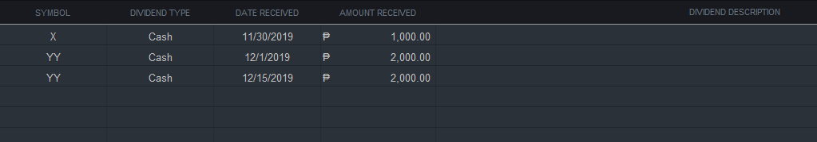
7- Trade Review – We have removed unnecessary columns in the trade review notes, make sure to paste your data per column.
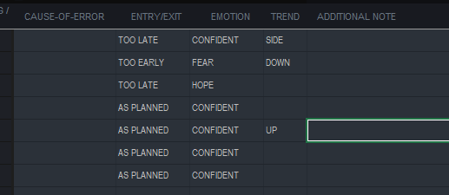

8- Optimizing Formula – You can optimize the spreadsheet performance by using the optimize formula feature by clicking on the rocket icon.
It will convert all formulas into values from your older logs and retain few rows with formulas as per image below.
Incase you want to make changes in your old logs, you may need to click the refresh icon, this will recalculate all the logs.
The notes column such as “setup” will not be affected if you make changes in your older trade logs, you don’t need to click refresh if you add new notes in your older logs.
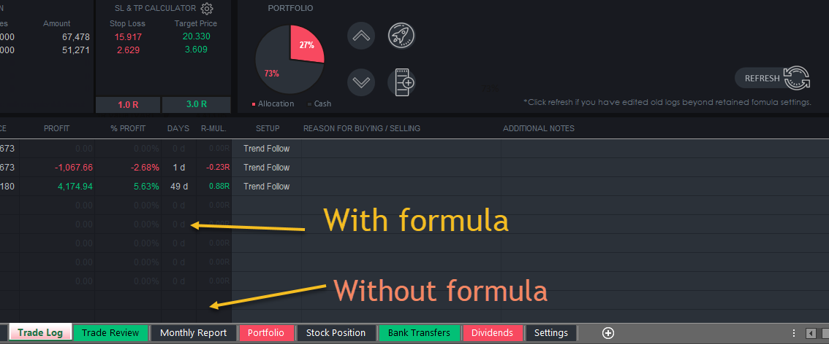
9- Trade Review – Click the refresh icon to update the trade review data if you make any changes in your trade log.
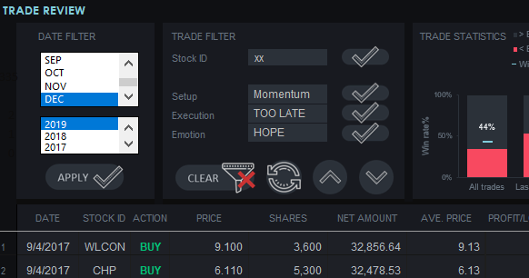

That’s it, contact us if you have any clarifications or questions. Thanks!

